**Shift invariance**: property that describes a system's unchanging response when the input is shifted;

useful in CNNs (e.g. obj recog.) vs **shift equivariance** (e.g. obj detection, segmentation)

**Assumptions**: translation invariance (ashift in input should simply lead to shift in the hidden representation) + locality

Pooling layer ensures ***approximate* translation invariance**

**Receptive field** of a layer k

For real-valued functions, of a continuous or discrete variable, conv = cross-correlation of f(x) & g(−x), or f(−x) & g(x)

**Convolutions & CNNs**

Output shape (width or height): **floor((W – K + 2P) / S) + 1**

Output shape (depth/num of channels): num of filters applied

Need to flip kernel horiz/vert.

Convolution:

#params of 1 filter: filter H x filter W x filter C + 1 (bias)

Conv = only equivariant to translation; not equivariant to

warp, flipping… hence data aug for better model general. too

CNN approx. invariant if adding pooling layers.

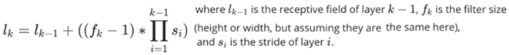

**CNN architecture**

- convolutions implemented through weight sharing, interpreted as weights of a filter function

- more output channels => NN can learn more complex + high-level features. Padding to preserve input shape.

- final FC layers: can be comp. + memory expensive (bottleneck w/ increasing num of classes, e.g. 1000 for ImageNet)

- 1x1 conv acts like an MLP per pixel, which aggregates across channels of input; introduces complexity + nonlinearity

- **AlexNet** for ImageNet: deeper + bigger/wider LeNet. Add dropout, sigmoid => ReLU, maxpool, heavy data aug, model ensembling (model averaging across multiple well-performing CNN models to achieve SOTA results) vs LeNet for MNIST

- **VGG**: group layers into blocks (num of blocks varies). Blocks can be easily parameterized, creating a more organized, modular arch. Simplifies design process + easier to fine-tune model for specific learning tasks.

- More layers of *narrow* convolutions outperforms using fewer *wide* ones: lots of simple fns > few complex fns

- **Inception**: deep + parallel paths with blocks to capture different types of features more effectively. Combines benefits of various convolutions & pooling operations while optimising computational cost

- **Batchnorm** normalises features within each minibatch, stabilising training process & speeding up convergence. Regulatisation by noise injection + no dropout needed (both control NN capacity) + ideal minibatch 64-256). B = batch. Test: fix the gamma & beta learned in training + instead batch statistics, use running average for mean and variance

- **ResNet**: get increasingly powerful AND nested functions (might not be convex) with more layers. “Taylor expansion” style parametrization. Input to act fn becomes f(x) ***+ x*** (x sometimes * with 1x1 conv to change dim). Allows for deeper NNs w/ fn classes more likely to be nested. Better grad flow (solve vanishing). ResNet module: multiple ResNet blocks.

- **DenseNet** uses higher-order Taylor series expansion; feature maps reuse; may need to reduce res (transition layer)

- **curse of dim**: As the number of features or dimensions grows, the amount of data we need to generalise accurately grows exponentially

- **pooling**: permutation-invariant aggregation + downsampling; reduces res; hierarchical features; max-pooling breaks shift equivariance. **Separable filter**: filter can be written as conv of 2/more simple filters: e.g. 2D filter from 1D filters; and det(filter)=0.

For correlation: it’s g(x + tau)



Tuto answers

**Reparametrization trick: directly sampling *z* from *q* and passing samples through the model to compute gradients is not differentiable wrt parameters ɸ of dist. from which *z* is drawn 🡪 hard to backpropagate**

*Gradient wrt KL term is tractable, MC still required for first term*

*Analytic form:*

**VAE optimization objective:**

**Variational auto-encoder approach defines *q* distribution as a neural network:**



**Variational Inference:**

Latent variable model: , often constructed as

Expand the above objective:

**MLE:**

given a dataset , we want to fit to a generative model with parameter theta:

Probabilistic graph models (joint distribution): used to describe dependency structure

**VAE**

The definition of divergence is weaker than distance: does not need to satisfy symmetry or triangle inequality

We can work with PDFs:

G𝜽 () defined as a neural network transform parametrized by weights theta. We optimize MLE objective wrt 𝜽, which involves computing integral 🡪 intractable as it computes non-linear transformation G𝜽(z) for every single configuration of z within Gaussian p(z)

**Monte Carlo estimation: is still intractable, so we replace expectation with MC approximation:**

We can ignore the constant terms wrt theta and instead work with the *maximum likelihood* object:

**KL Divergence: minimize this in order fit a distribution to a target one, asymmetric:**

A math symbols and signs

**Conditional VAE: generate data conditioned on additional information (class labels, viewing angle). *y* is the additional info**

Solution: use the variational lower bound as a tractable approximation to marginal log-likelihood



If ***x*** is cont., then G(z,y) is a neural network. We maximize a variational lower bound:



or minimize KL divergence:

**GAN.** Constructs a binary classification task to assist the learning of generative model dist. to fit data dist.

Logsigmoid: output is always negative

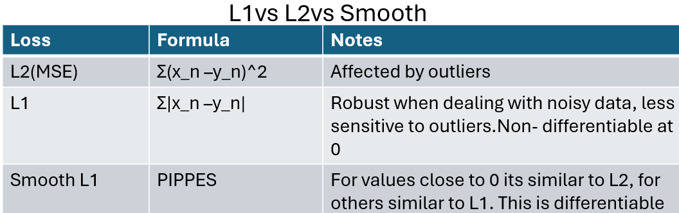

Fit a binary classifier (discriminator) by maximizing the MLE objective:



Generator fools discriminator by **minimizing** log prob. of making the **right** decisions

Two-player game objective for GAN is:



MC approximation: the evaluation of the obj. can directly define sampling process of , which also defines the distribution in an implicit way:

Jensen-Shannon divergence minimization: For a fixed generator, setting the gradient of GAN objective = 0 results in:

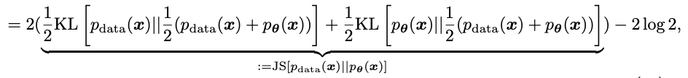



**Losses. L1/2/CE**: “reduce” to scalar using mean or sum.

**Smooth L1**:

**NLLL**:

**Derivatives** (g is the fn)

**Sigmoid:**

**Tanh:**

**ReLU:** 1 if z > 0, 0 if z <= 0

**Softmax (w/ CE loss):**

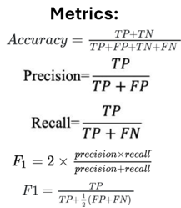

*Alternative ”non-saturated” objective given fixed discriminator:* Saturation problem (near-perfect classf. at start of training 🡪 vanishing gradient); so, **max**. log prob. of making **wrong** predictions.

**Conditional GAN**

Distribution form of p is defined implicitly by the sampling process:

Learning is done by optimizing an adversarial objective (similar to GAN, min max L(***x,y***) )

**CE loss:** combines logsoftmax(output) & NLLL. Use for classif. Average across obsv. within minibatch



**Binary CE loss:** CE loss for only 2 classes. Inputs as probas or logits

**(above) KL div. loss:** dist. btw proba distributions

**GRUs**

- improves simple RNN with gates like LSTM

- vs. LSTM: GRU removes the input/output gates and the cell state, but maintains the forgetting mechanism in some form

**RNNs**

- can model dependencies within a sequence of arbitrary length

**LSTMs**

- Weights/biases shared across cells; sigmoid and tanh activation fns; final output/prediction = short-term memory outputted from last cell

- different paths for long-term & short-term memories to avoid gradient vanishing/expl problem from RNNs

- memory cell states and gates to control error flows

Simple RNN computes this mapping at each t:

BPTT =>

Can truncate:

**Seq2seq models**

h0, c0 set to 0 or learnable. If 0, then we have the elems in c_t and h_t

- weights/biases = shared across cells, where each cell = single-layer NN with 1 input and 1 output at t. no matter #cells/timesteps, no increase in #learnable params! BUT **issue w/ gradients**: vanishing or exploding => diff to train.

Some **tricks**: grad clipping; good W_h init; unitary/orthog. W_h

Hyperparam lambda; clip ***g*** if

**Attention**

Single-head attention: *scaled dot product attention*

Multi-head attention: multiple alignment processes by projecting inputs into diff. subspaces, then performing dot product attention in subspace. Outputs are concatenated and projected

**Transformers**

*Position encoding: attention is equivariant to row permutations bc non-linearity a(.) is applied row-wise. Ordering info needs to be added to attention inputs, can either be learned or computed, learned*

is good if we know max value of index

*Sinusoid embedding: use multiple periodic functions to embed*

input index, frequency of sin/cos wave is det. by *i*.

Allows network to learn very flexible position encoding

function

Point wise feed forward network: used as ff layer, multi-head attention (after *Add&Norm*) returns a matrix of size N x d_out, which can be processed “point-wise”, treating rows in the attention outputs as “datapoint” inputs for next layer

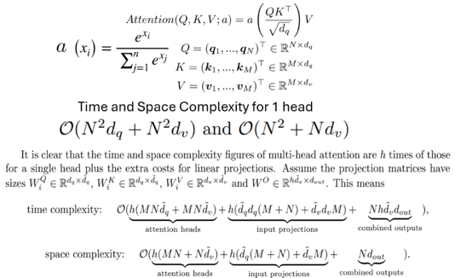

soft attention: a(.) is the softmax function,

hard attention: one-hot vector for each row with equal to 1





**Margin Ranking/Ranking/Contrastive Losses**

**FLOPs**

**Efficient training: grad accumul., checkpointing**

**Triplet Margin Loss**

**Cosine Embedding Loss**





**Finetuning**

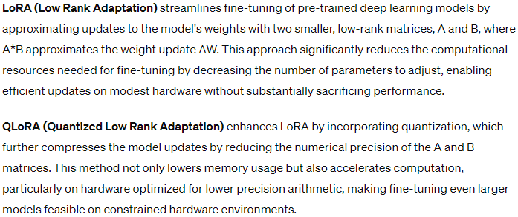

**GRU**

**LSTM**

**

**Conv**

* Don’t assume that in for a single kernel, the same kernel is applied to each channel of the input image
* Max pool and average pool are applied PER channel (not aggregating across channels of input image): only operate on width and height of input
* Mean and var learned gamma beta: to give new dist
* Valid padding = no padding at all
* Same padding = as much padding as needed to preserve the dims of input
* 0 padding needed for same padding: (K – 1) / 2
* Num of params for a conv layer with (more than 1) F filters of the same shape: F * (width of filter x height of filter x input channels + 1) where 1 is bc we have 1 bias per filter
* Batchnorm output: same shape as input. Num learnable params: 2 x num of channels in input. It’s 2 bc you have gamma and beta
* Pooling layers = no learnable params

**Backprop / gradients**

* Add the expression for dJ/dy_hat when using J = cross entropy loss with softmax being used:

1/m (y_hat – y)

* If largest singular value of a weight matrix > 1, then gradient explosion happens

**DAG**

* Conditional = joint / priors
  + Hence for q(z1,z2 | x1, x2): the priors of x1 and x2 cancel out and you don’t write them as factors